VEX IQ Level Up: Session 2 - Virtual Coding Station

Activity: Code Flop in VEX IQ Level Up Virtual Coding Skills!

- Go to vrskills.vex.com and select ‘autonomous coding skills’, or open VEXcode VR.
  - Select the IQ 26-27 Level Up Playground.
  - You need your Team Number and Virtual Skills Key to open the Playground.
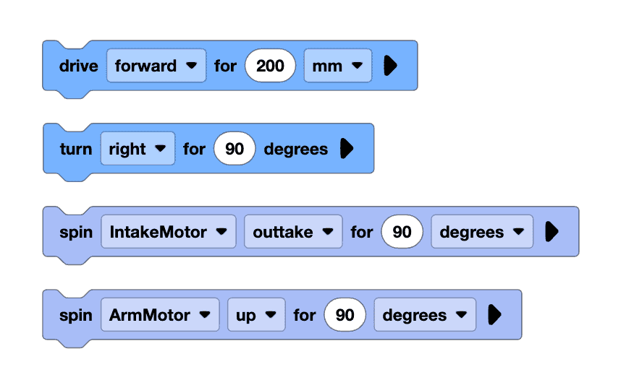
- Watch the recording of the robot driving to score the preloaded Yellow Bean Bag on the L1 Pyramid Goal, and drive to pick up a Blue Bean Bag.
  - Pay attention to the order of robot behaviors.

- Use the blocks shown to the right to code Flop to score the preloaded Yellow Bean Bag on the L1 Pyramid Goal, and drive to pick up a Blue Bean Bag.

- Run your project often to test it. If your robot doesn’t behave as you expected, try again!
VEXcode VR Reminders:
- Blocks will only run if they are attached to the When started block.
- Use the Reset button on the Playground to reset the field each time you test your project.
- Try changing the camera views to help you pick up Bean Bags.
- Try using the Navigation Kit to help you plan and code your project.
Feeling Stuck?
- Build and test your project one block at a time. This will help you understand the behavior Flop completes with each block.

Discussion Questions  - What scoring task would you like to code Flop to complete next?  - Why would you choose that scoring task?  - What blocks would you use to code it? | Activity Checklist  - Each team member watched the recording of Flop scoring a Yellow Bean Bag on the Pyramid Goal, and driving to pick up a Blue Bean Bag.  - Each team member added a block to the project.  - Flop successfully completed the task.

